**NAME : SANGEETHA.A**

**PROJECT TITLE : CREATE A REEL DESIGN USING CANVA**

**DEPARTMENT: COMPUTER SCIENCE AND ENGINEERING**

**COLLEGE : 8151-DHANALAKSHMI SRINIVASAN INSTITUTE OF TECHNOLOGY**

**COURSE DETAILS: DIGITAL MARKETING**

**TEAM ID : NM2023TMID03424**

**NM ID : 80C0FB5F1097B0F947949543AC0DA9E8**

**ZONE : 12**

**CREATE A REEL DESIGN USING CANVA**

1. **Launch Canva. Open Canva and search “Reels” to make IG reels.**
2. **Choose a reel template. Begin with a free, customizable reel template.**
3. **Upload your videos and photos.**
4. **Customize your reel. ...**
5. 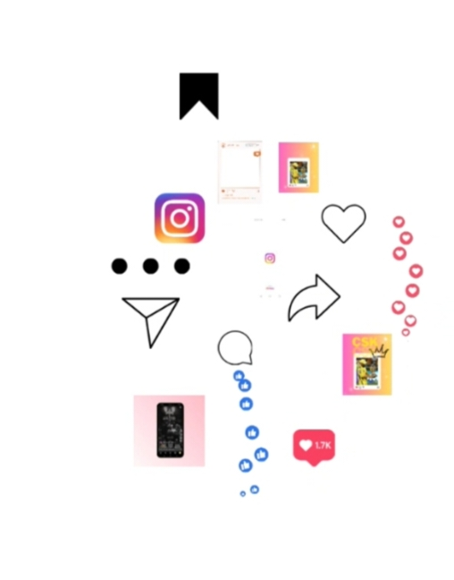**Download and share.**

**CREATE A REEL DESIGN USING CANVA**

**Step 1**

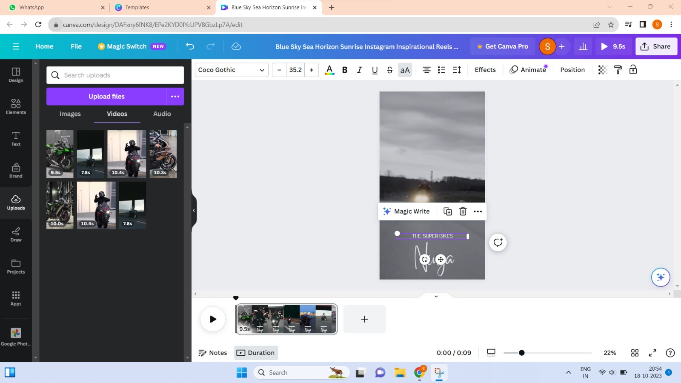

**Step 2:**

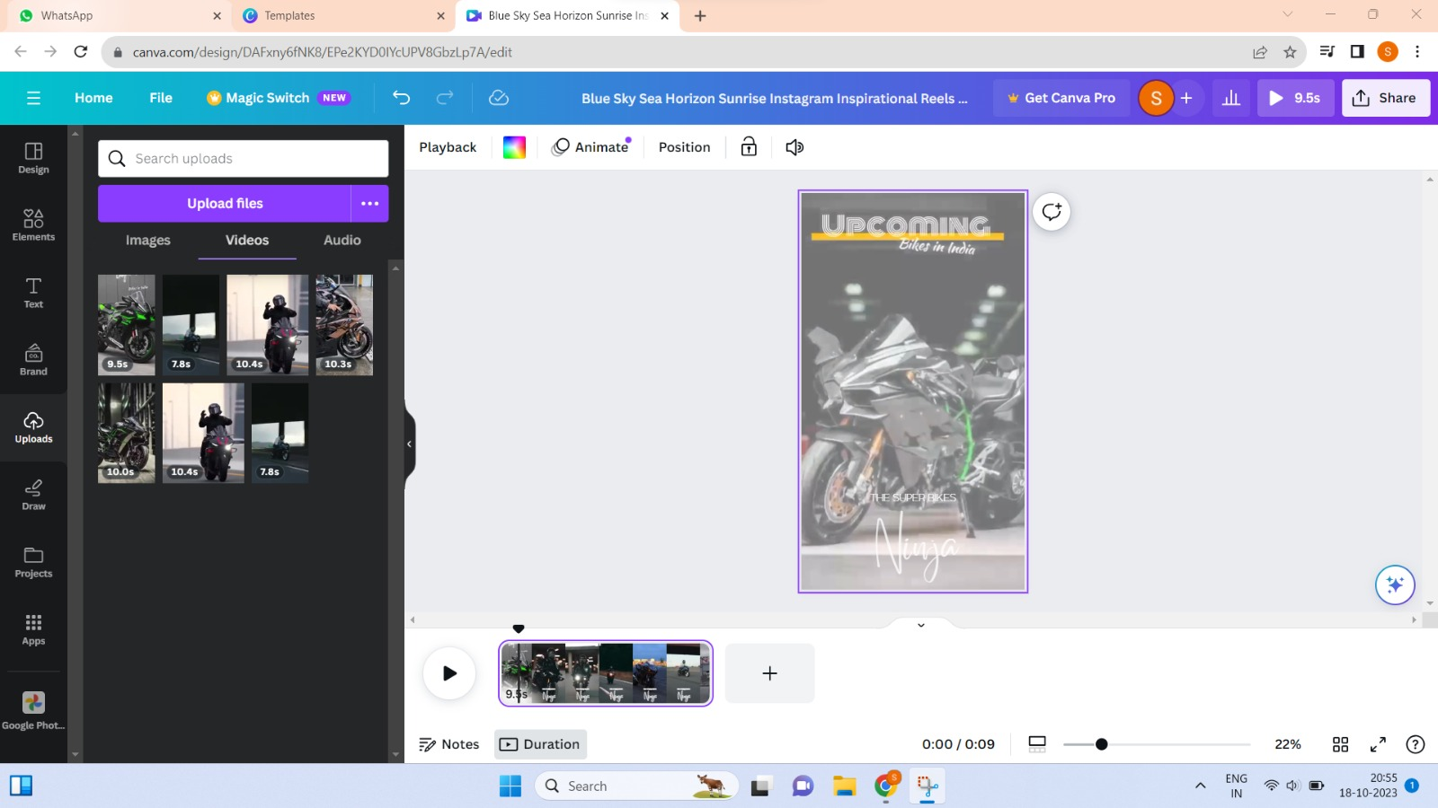

**Step 3:**

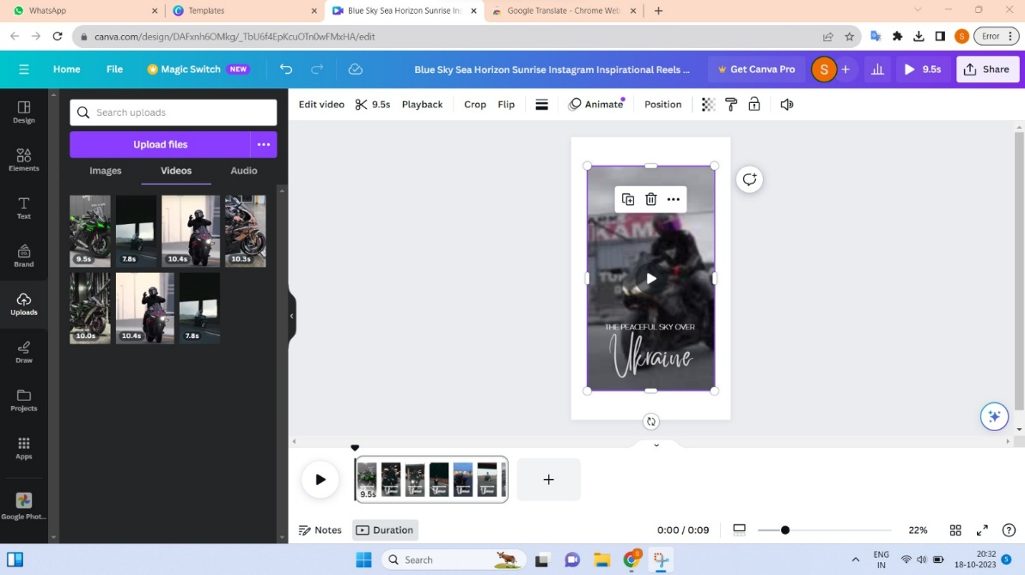

**Step 4: A Reel On Instagram**

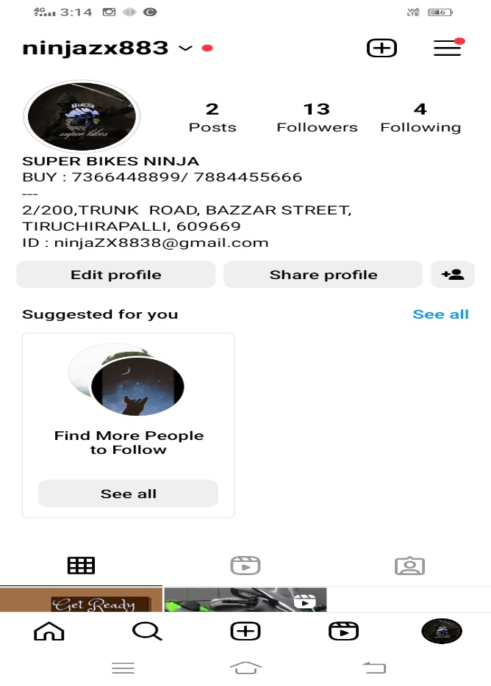

**Step 5:**

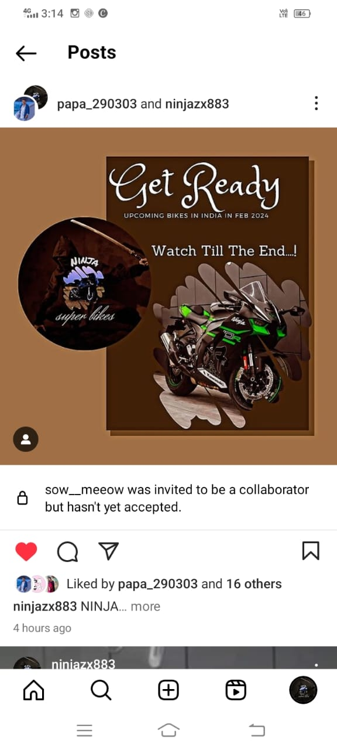

**Step 6:**

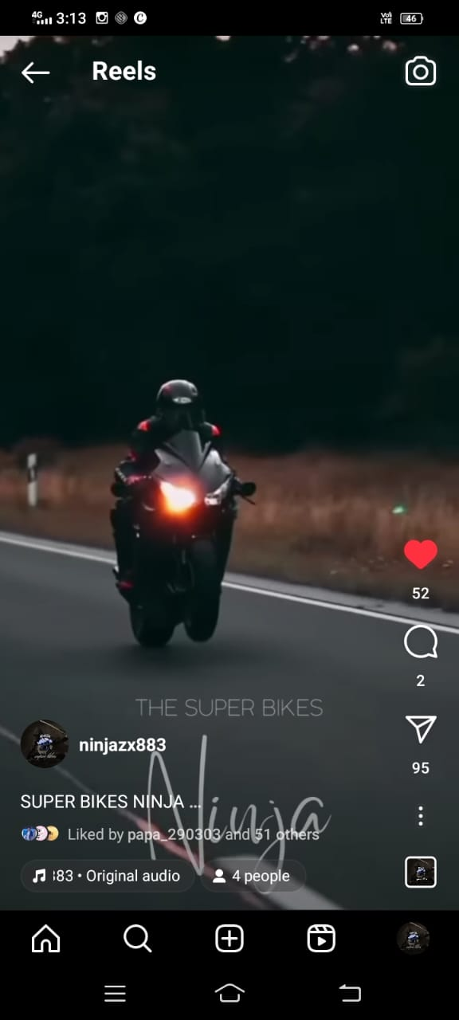

**Brand Name : Ninja Super Bikes**

**Category : Bike Marketing**

**Target Audience : All(Men,Women and Adults)**

**Email :** [**ninjaZX8838@gmail.com**](mailto:ninjaZX8838@gmail.com)

**Instagram Video Link :**

[**https://www.instagram.com/reel/CykcD2Nrpd5/?igshid=MzRlODBiNWFlZA==**](https://www.instagram.com/reel/CykcD2Nrpd5/?igshid=MzRlODBiNWFlZA==)

**Instagram Profile Link :**

[**https://instagram.com/ninjazx883?igshid=OGQ5ZDc2ODk2ZA==**](https://instagram.com/ninjazx883?igshid=OGQ5ZDc2ODk2ZA==)

**Demo Video Link :**

[**https://drive.google.com/file/d/1iNNARC1co5Ethhual5RA7BAvbsYMeFsm/view?usp=share_link**](https://drive.google.com/file/d/1iNNARC1co5Ethhual5RA7BAvbsYMeFsm/view?usp=share_link)

**Demo YouTube link :**

[**https://youtu.be/VV8Nhr8ErAY?feature=shared**](https://youtu.be/VV8Nhr8ErAY?feature=shared)